3-14

Start the project. I plan to design a game, refer to the games Teeter and Supermonkey ball, and make a 3D rolling ball game with a bird's-eye view. Let the player control a wooden platform, and make a small ball roll from the starting point to the end point by tilting. There will be some holes in the journey that make the player fall, and the player needs to finely control the ball to bypass the small hole. There will probably be three levels in the game, and the player's goal is to reach the end of the final level. Draw a rough design sketch and determine the general appearance of the game.

3-15

A test board was built in Unity. A level consists of the following items: a bottom board, surrounding boards to prevent the ball from falling out, some obstacle boards, and some holes. Since it is impossible to dig a hole in the cube, a cylinder is used instead of the hole, and a black cylinder with a thickness of 0.0001 thicker than the bottom plate is used as the hole. Created a small sphere and used the default material.

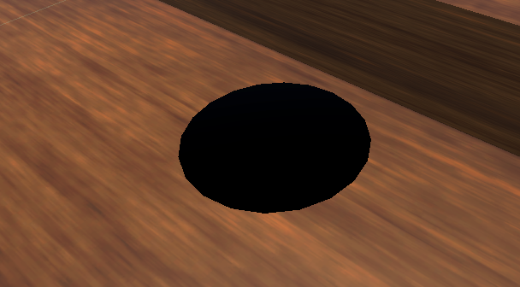

3-16

According to the game design document, it is planned to add texture maps to the game board. I selected a free wood grain material in Unity's material store, downloaded the material, imported the material, and added the material to the level. The default material of the ball is a bit different from what I imagined, so I decided to change the material of the ball to stainless steel. I chose the metal material in Unity’s material store. After downloading and importing it, I found that it was different from what I imagined. So I created the material in Unity and set the metal feeling and reflection of the material to the highest to imitate the texture of metal. The effect is not bad.

3-17

Wrote the first version of the player control script, using "transform.Rotate" to rotate the board. And when the player doesn't press the button, the board gradually returns to the level. After testing, the wooden board can rotate normally, but because the quality of the small ball is too light, sometimes mold penetration will occur, or the small ball will fly into the air when the wooden board is rotated too fast. Unable to resolve at this time.

3-18

Try to continue to solve the problem, set the mass and gravity of the ball higher to try to make the ball stick to the board, but it doesn't work. Try to make a script for the death mechanism. The principle is that when the ball hits the collision box of the cylinder, the position of the ball and the inclination angle of the board are reset.

3-19~3-21

Think about how to make the ball stick to the board, query various materials, and find solutions from Unity documents and Youtube videos, but nothing is gained.

3-22

Decided to change how the board was modeled, queried different modeling methods, and finally decided to use ProBuilder to model the hole from the top surface of a cylinder to a real hole.

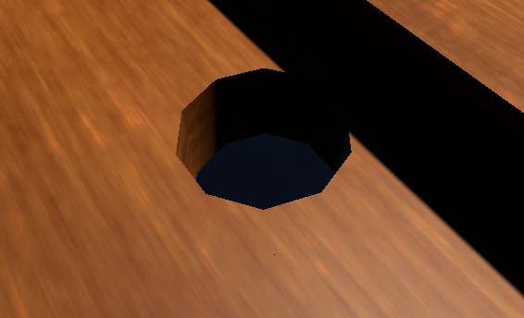

3-23

Use probuild to make the first level and the second level. During the production, it was found that when you cut too many holes on the board, the calculation time required for each cutting will increase geometrically, so the subsequent levels cannot Make it harder by increasing the number of holes.

3-24

Make a script so that the ball enters the second level when it reaches the end of the first level. The method used is to destroy the game object of the first level and move the wooden board of the second level to the designated position.

4-3

Back at school, I asked the teacher for advice. According to the teacher's suggestion, "transform.Rotate" was changed to "playerRb.MoveRotation" to fix the problem of mold penetration, but new problems appeared: 1. This movement method can only move in four directions, front, back, left, and right, and cannot move to Front left, front right, back left, back right. 2. This method cannot fix the y-axis of the board. In practical applications, the y-axis of the board will gradually shift. In addition, the method of gravity of the ball is changed, from directly changing the value of gravity to using "body.AddForce(new Vector3(0, -500, 0));" to continuously give the ball a downward force to make it tight Attach the planks and add an air wall above the planks.

4-4

Added left front, right front, left rear, right rear movement methods, and added back-to-center function. The problem of y-axis offset is still not solved.

4-5

Asked the teacher, rewrote the player control script again, deleted all the previous codes, and changed "playerRb.MoveRotation" to

"transform.rotation.eulerAngles" solves the problem of rotation in multiple directions and the problem of y-axis offset at the same time, and greatly simplifies the code.

4-6

The third level was built directly using cubes, because the probuilder cannot make a large number of cuts. Added "next level" script to level 2.

4-17

Ask the teacher for advice. Add game UI, add timer UI and corresponding scripts. At the end of the third level, an end-game script is added. When the player touches the end of the third level, an end interface will be called, and a button will be attached to allow the player to reset the game book. Browsed the Unity store, downloaded and added a skybox.

4-18

Ask the teacher for advice and add the code "deltaAxis = new Vector2(Input.GetAxis("Horizontal"), Input.GetAxis("Vertical"));" so that the player can manipulate the wooden board through the handle or keyboard, and the rotating The code was changed to "Quaternion.RotateTowards" which limits the maximum movement speed of the planks. In the end, I achieved the rotation of the board with a very short code.

4-19

Try the first conversation, under the teacher's suggestion, rewrite the Logbook to make it more detailed; add the Design DOC to make it more detailed; give the game a name "BALLance"; add a start interface to the game, and Added a watermark to the start screen.

4-24

Second conversation. Based on the teacher's suggestion, the game design document was changed.